Penetration Testing Lab

Student Name: Arr Domingo
Course / Section: CYBR3090 – Cyberthreat Intelligence / O01, O02.1252
Instructor: Sam El-Awour / Garfield De'Pluzer
Due Date: February 27, 2026

Table of Contents
Part 1 - Netcraft 1
Part 1.1 - https://www.accenture.com 1
Part 1.1.1 Netblock Owner 2
Part 1.1.2 IP Address and Autonomous Systems 3
Part 1.1.3 SSL Certificate Information 4
Part 1.1.4 Nameservers, Domain Registrar, and Organisation 5
Part 1.2 https://www.edmontonpolice.ca 6
Part 1.2.1 Public key algorithm 6
Part 1.2.2 Server 7
Part 1.2.3 Cipher 8
Part 1.2.4 DNS admin 9
Part 2 – Whois Lookups 9
Part 3 – DNS Reconnaissance 11
Part 3.1 “A” record type 12
Part 3.2 “MX” record type 12
Part 4 – Nmap and NetCat (NC) 12
Part 5 - Metasploit 13
END 1

Part 1 - Netcraft
- Go to https://www.netcraft.com/
- Go to “Resources” menu and click “Research Tools”.
- Click “SITE REPORT”, or go directly to https://sitereport.netcraft.com/
- Paste the two different websites.
- Click “Look Up”.

Part 1.1 - https://www.accenture.com
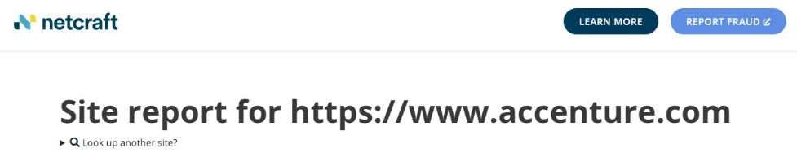
Figure 1. Netcraft lookup for accenture.com

Part 1.1.1 Netblock Owner
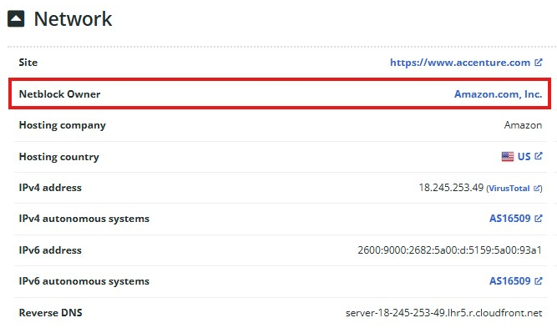
Figure 2. Netblock Owner of accenture.com
The “Netblock Owner” is “Amazon.com, Inc”. Knowing this tells the pen tester where the website infrastructure physically runs and which cloud provider tech support may be responsible. This can point to default configurations or known security settings common to that provider.

Part 1.1.2 IP Address and Autonomous Systems
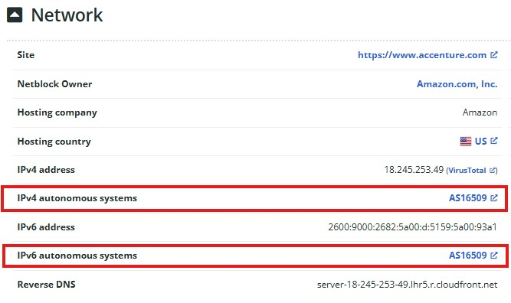
Figure 3. IP Address Autonomous Systems of accenture.com
The “IPv4 autonomous systems” is “AS16509”, while the “IPv6 autonomous systems” is “AS16509”. This data is important in reconnaissance as it helps to understand the network segment the site is on. This helps with mapping out the target’s internet footprint and possible related services. It is also important when planning further scanning.

Part 1.1.3 SSL Certificate Information
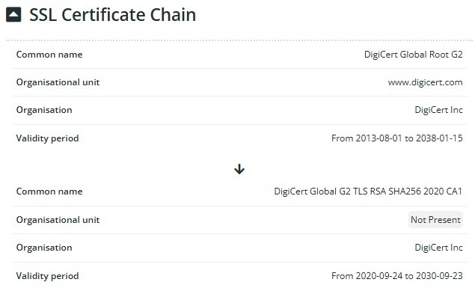
Figure 4. SSL certificate information of accenture.com
SSL certificate details show encryption practices. The certificate issuer can reveal trusted third-party providers. Older or incorrect configured certificates can indicate poor security practices and vulnerabilities.

Part 1.1.4 Nameservers, Domain Registrar, and Organisation
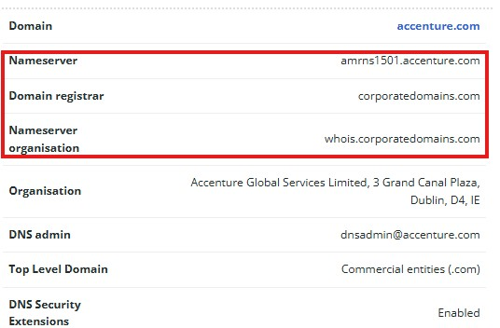
Figure 5. Nameserver, Domain registrar, and Nameserver organisation of accenture.com
The Nameserver is “amrns1501.accenture.com”, Domain registrar is “corporatedomains.com”, and Nameserver organisation is “whois.corporatedomains.com”. This information helps in planning how DNS might be structured and potential attack surface like DNS zone transfer, which is the process of replicating DNS database records from a primary (master) DNS server to a secondary (slave) server.

Part 1.2 https://www.edmontonpolice.ca
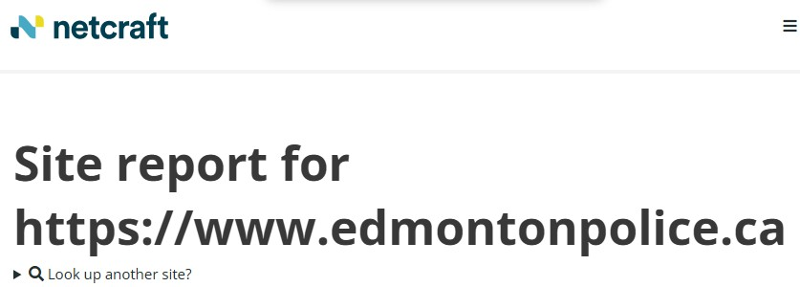
Figure 6. Netcraft lookup for edmontonpolice.ca

Part 1.2.1 Public key algorithm
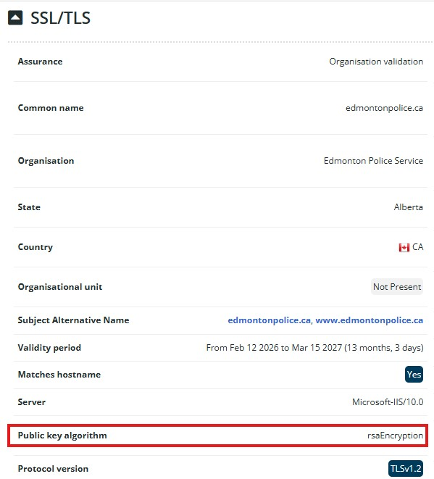
Figure 7. Public key algorithm of edmontonpolice.ca
The Public key algorithm of Edmonton police website is “rsaEncryption”. This is useful in reconnaissance as it tells how encryption is implemented for secure HTTPS communication. During reconnaissance, identifying the encryption algorithm helps determine whether the organization is using modern cryptographic standards. Strong encryption suggests proper security hygiene, while weak cryptography could present potential attack vectors.

Part 1.2.2 Server
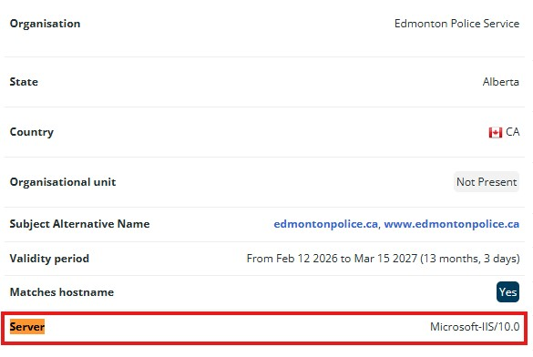
Figure 8. Server of edmontonpolice.ca
The website is running “Microsoft-IIS/10.0” as its web server software. Identifying the web server tells us what software is handling HTTP/HTTPS requests. Knowing the server type helps narrow down potential vulnerabilities, since different web servers (IIS, Apache, Nginx) have different known CVEs. The version number (10.0) is especially important because penetration testers can check vulnerability databases for known issues specific to that version.

Part 1.2.3 Cipher
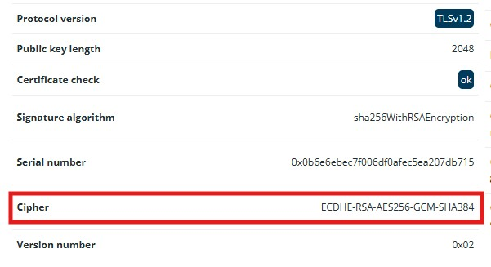
Figure 9. Cipher of edmontonpolice.ca
The website uses the cipher suite ECDHE-RSA-AES256-GCM-SHA384 for secure HTTPS connections. A cipher suite defines how encrypted communication is established between a client and server. This indicates the organization is using modern and secure cryptographic standards. Strong cipher suites reduce the risk of downgrade attacks or weak encryption exploits. Evaluating cipher strength helps assess the overall security posture of the target.

Part 1.2.4 DNS admin
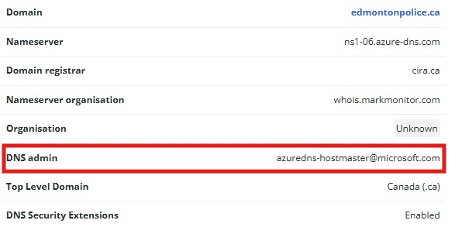
Figure 10. DNS admin of edmontonpolice.ca
The DNS admin is listed as azuredns-hostmaster@microsoft.com. This indicates that the domain’s DNS is managed through Microsoft Azure DNS. Knowing the DNS provider helps identify part of the organization’s cloud footprint. It also confirms reliance on a third-party cloud provider, which influences how infrastructure is structured.

Part 2 – Whois Lookups
- Open Kali Linux terminal.
- Type “whois joineps.ca”. (Replace joineps.ca with a domain of your choice)
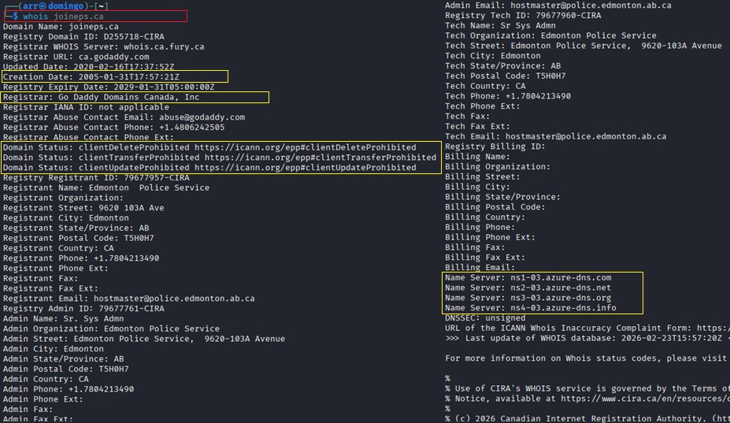
Figure 11. Passive reconnaissance using WHOIS.
Useful information for reconnaissance on a target:
- Registrar
“Go Daddy Domains Canada, Inc” is the registrar of the website. This is useful as it identifies the company responsible for managing the domain registration. It also helps determine where DNS or domain-related changes would be managed. If a registrar account were compromised (for example, through phishing), an attacker could potentially modify DNS records and redirect traffic. Knowing the registrar helps identify where domain security controls such as domain locking are enforced, therefore, it helps assess the domain management security posture.
- Creation Date
This information is useful as it shows how long the organization has owned the domain. Older domains may have legacy systems attached to them that could be outdated or less secure. This helps assess maturity and possible outdated infrastructure. Understanding domain age helps evaluate potential risk factors.
- Name Servers
This information reveals DNS provider. This helps identify whether DNS is hosted internally or through a third-party service (e.g., cloud provider). It helps in mapping external dependencies. DNS information is critical when building a network footprint of a target.
- Domain Status
For joineps.ca website, the domain statuses are clientDeleteProhibited, clientTransferProhibited, and clientUpdateProhibited. This status indicates domain lock protection. Certain status codes indicate whether the domain is active, on hold, or restricted. If not locked, the domain could potentially be vulnerable to transfer attacks. Proper domain status settings reduce the risk of domain hijacking.

Part 3 – DNS Reconnaissance
Domain Name System (DNS) servers can also be used to learn more about domains. DNS servers translate human-readable URLs (www.google.com) into an IP address (142.250.217.110). DNS reconnaissance is concerned with identifying who owns a particular domain or series of IP addresses, the DNS information defining the actual domain names and IP addresses assigned to the target and the route between the penetration tester or the attacker and the final target.
The command nslookup can be used to return the IP addresses associated with a URL.
Entering nslookup into a terminal will result in a prompt (>) being displayed, indicating the system is awaiting input. This is where you enter the URL you wish to query.
It is also possible to search for specific record types (A, AAAA, MX, etc.) using nslookup by entering the command:
nslookup
> set type=record_type
> www.google.com
You can also query for different record types: A, AAAA, CNAME, NS, TXT, MX.
Use nslookup to query a URL (not google). Run a second query and search for one of the following record types: A, MX and briefly summarize the information gathered. (4 marks)

Part 3.1 “A” record type
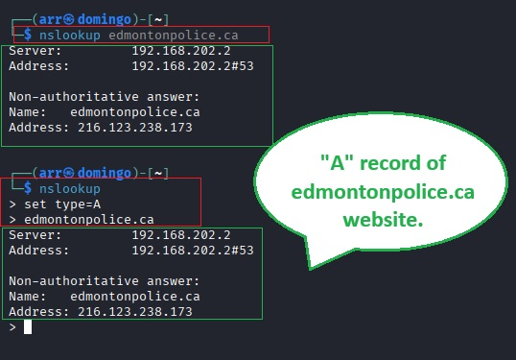
Figure 12. "A" record type result of edmontonpolice.ca
Information Gathered:
- The A record returned the IPv4 address associated with edmontonpolice.ca.
- It also showed the DNS server that responded to the query.
The A record reveals the IP address that the domain resolves to. This is important because:
- It identifies the actual server hosting the website.
- It allows mapping of the organization’s web infrastructure.
- It helps determine whether the site is hosted on cloud infrastructure or private hosting.
- The IP address can be used (in authorized testing environments only) for further network analysis.
The A record is a foundational piece of DNS reconnaissance because it connects the domain name to a reachable network resource.

Part 3.2 “MX” record type
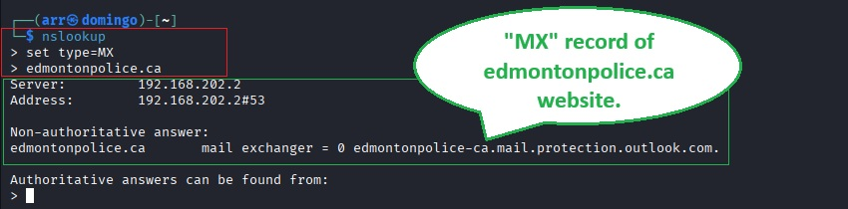
Figure 13. "MX" record type result of edmontonpolice.ca
Information Gathered:
- The MX record returned one or more mail exchange servers.
- It may show a mail server such as something associated with Microsoft 365 (for example, .mail.protection.outlook.com).
MX records identify the servers responsible for handling email for the domain. This is useful because:
- It reveals additional infrastructure beyond the web server.
- It may indicate whether the organization uses a third-party email provider (such as Microsoft 365).
- Email systems are common targets in phishing and social engineering attacks.
- Identifying mail servers helps expand the known attack surface of the organization.
DNS reconnaissance provides insight into both web and email infrastructure, helping build a clearer picture of the organization’s external footprint.

Part 4 – Nmap and NetCat (NC)

Part 4.1 Nmap scan for Xmas tree, SYN, and Protocol
We will use Nmap to scan for vulnerabilities on our infrastructure. Note: while using Nmap if the target Windows FW(firewall) is enabled, it will be blocking Nmap by default. You will need to figure out how to accomplish doing the scan without turning off the FW or in a worst-case scenario please turn it off. From your Kali Linux VM, run the following Nmap scans (with the Verbose flag) on the IP range for all VMs. Briefly highlight what switch(s)/parameter(s) are associated with a - c and explain their purposes with Nmap. (6 marks)
  - Xmas tree scan
  - SYN scan
  - Protocol scan
- On your local/host machine, open “Hyper-V Manager”.
- Highlight the virtual machine and press “Connect”.
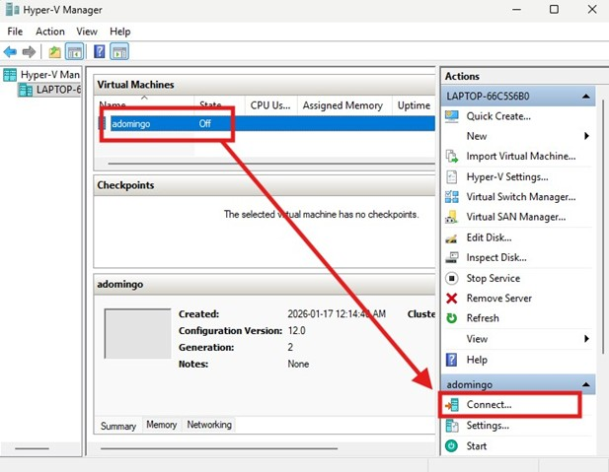
Figure 14. Connect the virtual machine.
- A window will appear, click Start.
- An option to adjust the desktop size will appear. Adjust based on your preference and click Connect.
- Use the password (without the double quotation) “Cyber3090” to login to Administrator.
- Once inside Administrator account, click Windows and search for “Hyper-V Manager”.
- In here, there are four virtual machines. However, due to the limited memory capacity of my machine, I can only run three virtual machines.
- Connect the three virtual machines: Kali-Linux, Metasploitable2, WinXPSP3. Use below credentials:
Devices Username Password
Kali-Linux kali Cyber3090
Win Server Administrator Cyber3090
Win XP Administrator Cyber3090
Win10 Administrator Cyber3090
MetaSploitable2 msfadmin Cyber3090

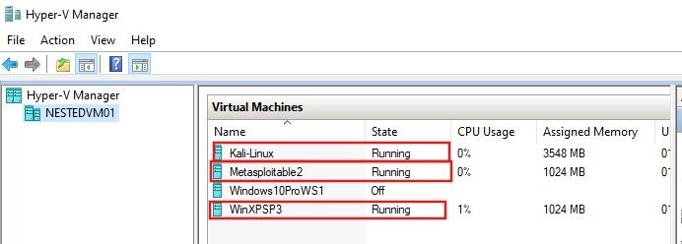
Figure 15. Three virtual machines are running.

Part 4.1.1 Xmas tree scan
- Open Kali Linux terminal and run the command “nmap -sX -v 192.168.1.0/24”.
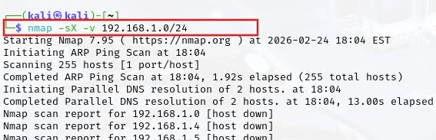
Figure 16. Nmap xmas tree scan.
Switch Explanation:
- -sX Xmas Tree scan
- -v Verbose output
What it Does:
- Send packets with FIN, PSH, and URG flags set.
- Used to attempt bypassing some firewall rules.
- Open ports typically give no response.
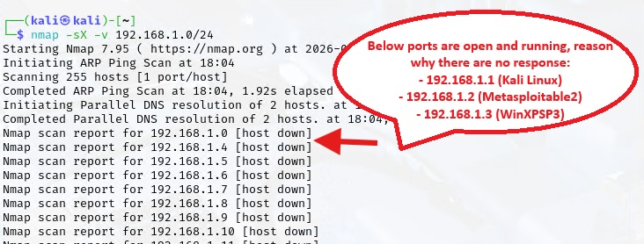
Figure 17. No response for open ports.
- Closed ports respond with RST (reset).
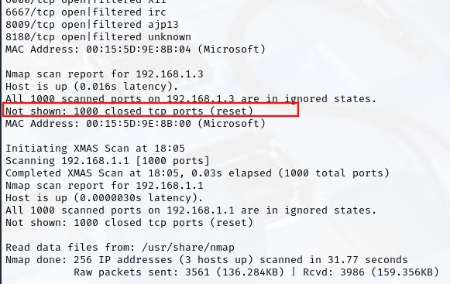
Figure 18. Reset response for closed ports.
Why it is Used:
- Can sometimes evade basic firewall logging.
- Useful for identifying filtered vs closed ports.
- Works better against Unix/Linux systems than Windows.
Scan Result:
- Xmas tree scan found that three hosts are up after scanning 256 IP addresses. This is true as Kali-Linux (192.168.1.1), Metasplotable2 (192.168.1.2), and WinXPSP3 (192.168.1.3) are all connected to the same network.
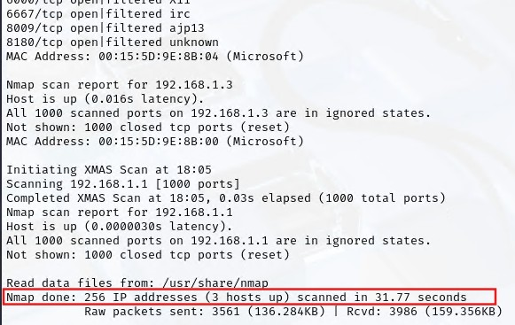
Figure 19. Xmas tree scan result.

Part 4.1.2 SYN scan
- Open Kali Linux terminal and run the command “nmap -sS -v 192.168.1.0/24”.
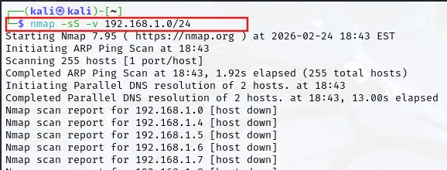
Figure 20. Nmap SYN scan.
Switch Explanation:
- -sS SYN scan
- -v Verbose
What it Does:
- Sends SYN packet (start of TCP handshake).
- If SYN-ACK received → port is open.
- If RST received → port is closed.
- Does NOT complete full handshake.
Why it is important:
- Stealthier than full connect scan.
- Faster.
- Most commonly used Nmap scan.
- Often called “half-open scan”.
Scan Result:
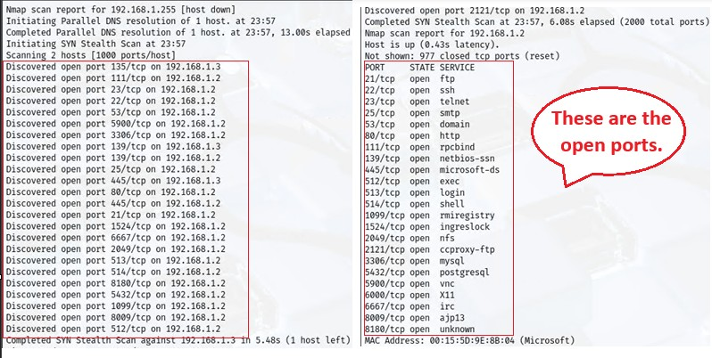
Figure 21. Open ports in nmap syn scan.
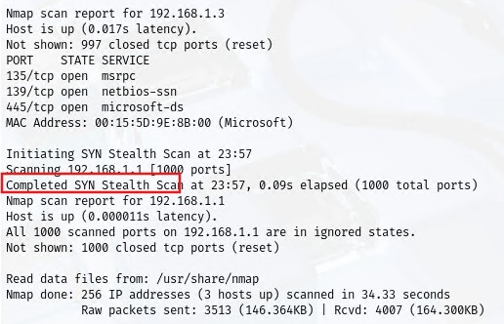
Figure 22. Completed SYN scan.

Part4.1.3 Protocol scan
- Open Kali Linux terminal and run the command “nmap -sO -v 192.168.1.0/24”.
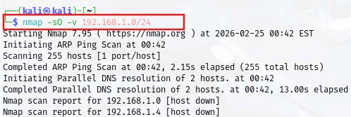
Figure 23. Nmap protocol scan.
Switch Explained:
- -sO Protocol scan
- -v Verbose
What It Does:
- Identifies which IP protocols are supported (TCP, UDP, ICMP, etc.)
- Does NOT scan ports, instead it checks protocol numbers.
Why It’s Useful:
- Reveals supported network layer protocols.
- Helps identify unusual protocol usage.
- Useful for mapping deeper network stack configuration.
Scan Result:
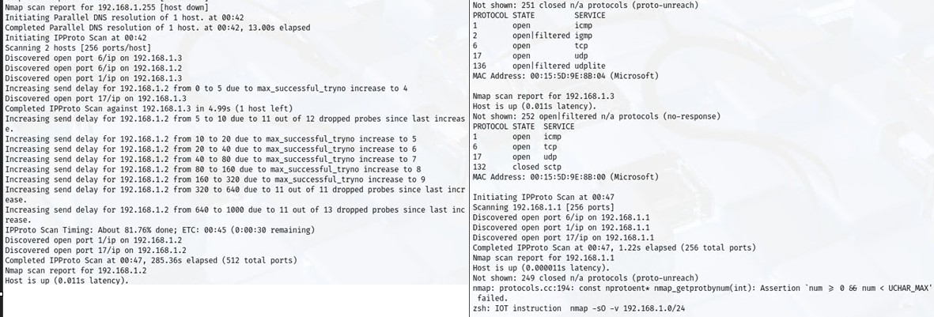
Figure 24. Nmap protocol scan result

Part 4.2 Using Nmap + Netcat
Use Nmap to scan for open ports on all VMs. After the scan, use “netcat” to find which port has known vulnerability(s). (4 marks)

- Open Kali Linux terminal and run the command “nmap 192.168.1.0/24”. This command will scan open ports for the entire LAN.
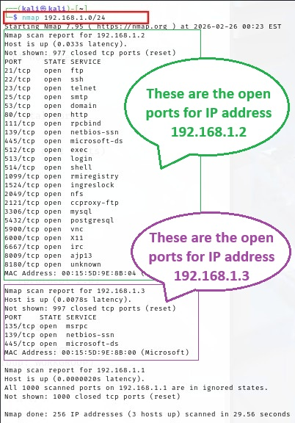
Figure 25. Nmap scan for entire network.
- To find which port has known vulnerabilities, use “netcat” command. Run “nc 192.168.1.2 21” where 21 is the open port for the specific IP address.
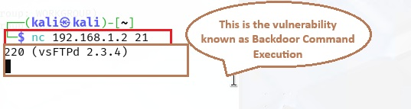
Figure 26. Netcat command to find the vulnerability of open port 21.
This vulnerability is commonly known as Backdoor Command Execution that has a CVE of 2011-2523 (https://www.exploit-db.com/exploits/49757).
Summary:
Nmap was used to identify open ports and services running on each VM. After identifying open ports, Netcat was used to manually connect to those ports and retrieve banner information. Banner grabbing can reveal software versions, which can then be checked against known vulnerabilities in CVE databases.

Part 4.3 Nmap Evasion (Decoy Technique)
For this section you will need to use Nmap to scan your network but if the packets are being captured you will want to make sure your Nmap scanner (Kali VM) is not identified as the sources machine doing the scanning. You will need to figure out the parameters/switches used to accomplish this task as well as to use screencaps from Wireshark to show the result is a success. Use screenshots to aid your outcome. (4 marks)
- Open Kali Linux terminal and type the command “nmap -sS -D RND:3 192.168.1.2” (don’t press enter yet). This command means:
- -sS TCP SYN scan (stealth scan)
- -D Initiates the decoy scan
- RND:3 Generate 3 random, non-reserved IP addresses as decoys to mask your scan
- 192.168.1.2 Target IP that has open ports
Explanation:
This makes the target (192.168.1.2) think it is being scanned by random IP addresses (random decoy IP).
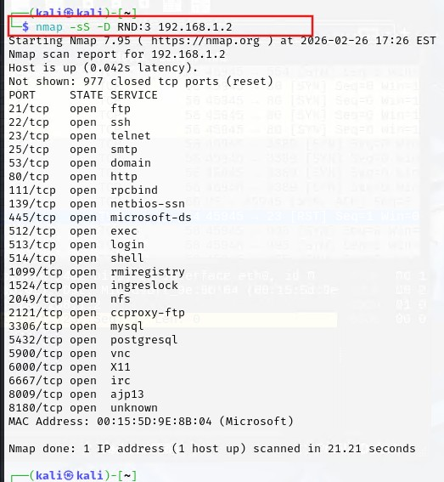
Figure 27. Command for nmap evasion using decoy technique.
- Still in Kali Linux virtual machine, open Wireshark.
- Click on “eth0”.
- Click the “Start capturing packets” or the shark’s fin icon.
- Go back to the terminal and enter the command typed earlier.
- Notice that Wireshark starts to capture the packets. Once the scan is done in terminal, press the “Stop capturing packets” icon in Wireshark. Below is the screenshot of the packet capture for decoy technique in Wireshark.
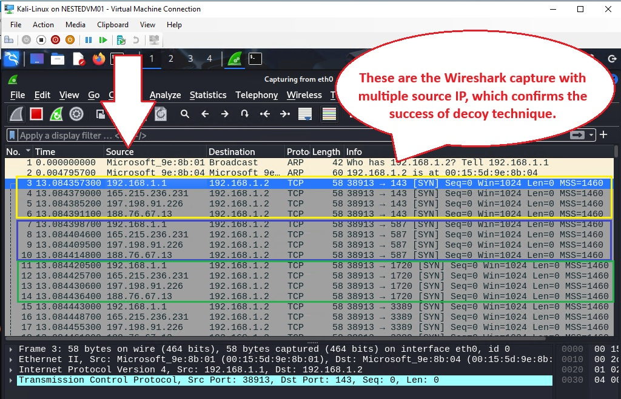
Figure 28. Success decoy technique.
Summary:
The -D switch was used to enable decoy scanning. This causes Nmap to send packets appearing to originate from multiple IP addresses, making it more difficult to identify the true source of the scan. Wireshark captures showed multiple source IP addresses, confirming the decoy technique was successful.

Part 5 – Metasploit
For this section, you are required to do a short 5-minute video demonstrating how you exploited the VMs/targets. Explain your process by showing which tool (Exploits and payloads) you used and what action(s) you were able to perform after exploiting the target. Note you are not restricted with regards to any action to perform once accessed the target.

Part 5.1 For Metasploitable2 VM

Part 5.1.1 FTP login exploit
    - Execute the FTP login exploit (2 marks).
- (Quite similar to Part 4.2) Open Kali Linux terminal and run the command “nmap 192.168.1.2/24”, where 192.168.1.2 is the IP address of Metasploitable2 VM. This command will basically scan open ports for Metasploitable2 VM. As for the result, “ftp” service is open with port 21.
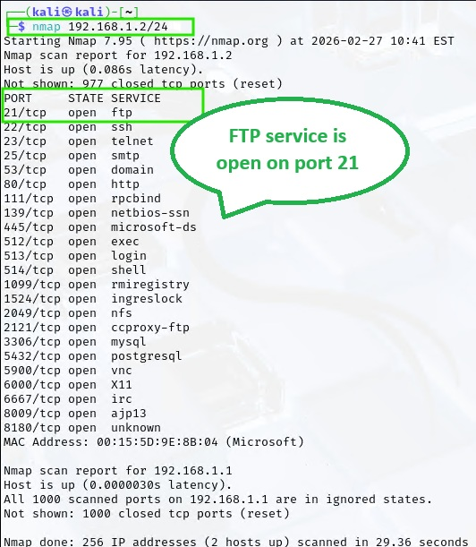
Figure 29. Port 21 is open for FTP service.
- To find known vulnerabilities for port 21, use “netcat” command. Run “nc 192.168.1.2 21” where 21 is the open port for FTP service. The vulnerability will show “220 (vsFTPd 2.3.4)”
Figure 30. Netcat command to find the vulnerability of open port 21.
- Open a separate Kali Linux terminal and type “msfconsole”.
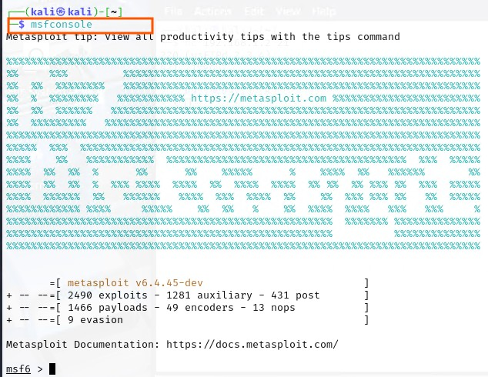
Figure 31. Command msfconsole.
- Type “search vsftpd” to search for FTP exploit.
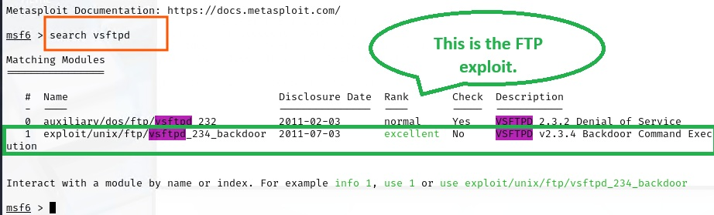
Figure 32. FTP exploit. Notice the “excellent” rank.
- Type “use 1” or “use <name of exploit>” to select/use the exploit module.
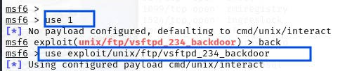
Figure 33. Use command.
- Type “show options” to show module information.
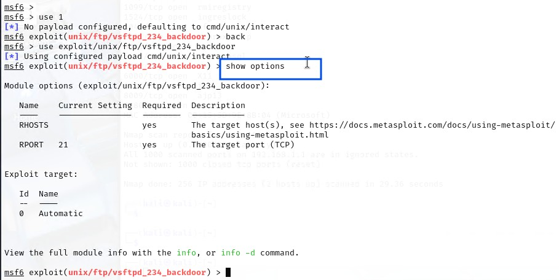
Figure 34. To show module info.
- Since payload details is not showing, type “show payloads” to check the payload details if you do not know it.
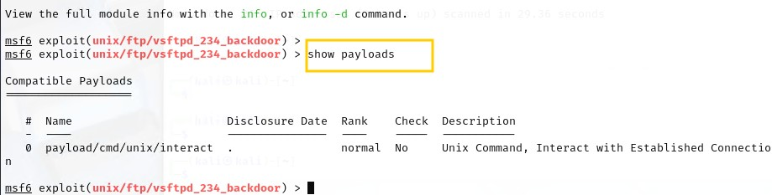
Figure 35. Payload details.
- To set the payload, type “set payload 0” where 0 is the number of payloads.
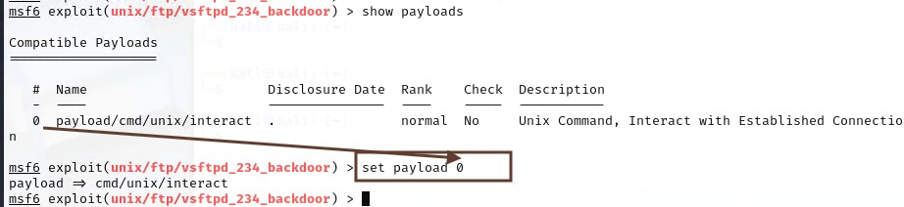
Figure 36. Set payload.
- Set rhosts or the remote host by typing the command “set rhosts 192.168.1.2” where 192.168.1.2 is the IP address of Metasploitable2 VM. After that, type “show options” to double check it rhosts is set properly.
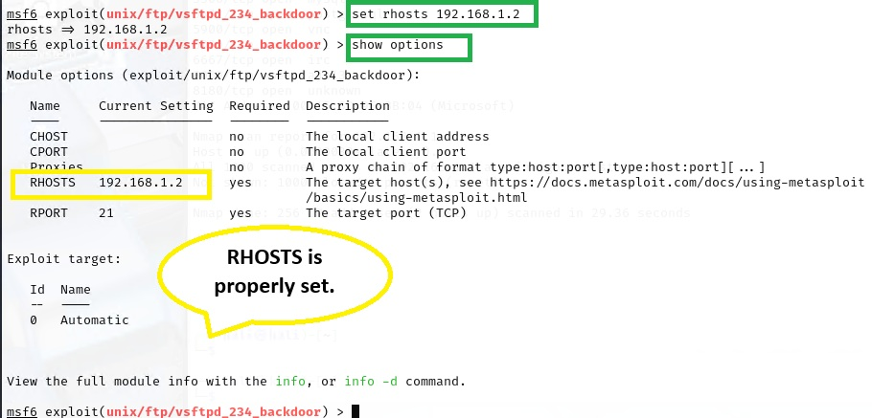
Figure 37. Set rhosts.
- Type the command “exploit”. This command is used to run the exploit. Take note that you need to run the command couple times until you are able to see a message “Found shell”.
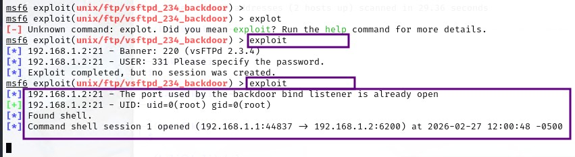
Figure 38. Run the exploit.
- At this point, you are now connected to the system. You can now run the commands “whoami”, “ls”, “shell”, and “c” to go to C drive of Metasploitable2.
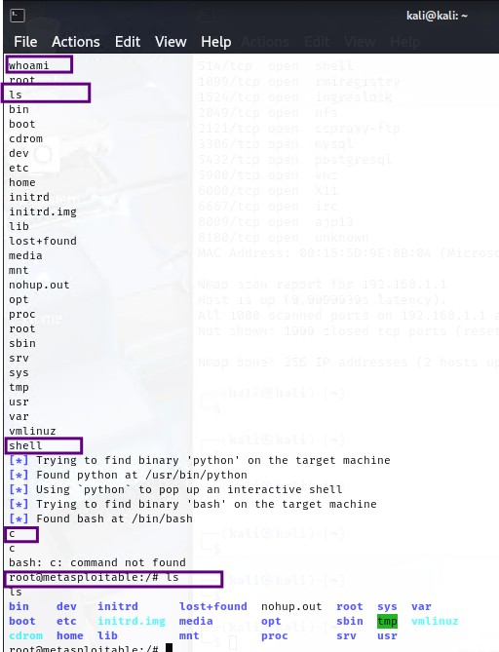
Figure 39. Successful connection to exploit the target(Metasploitable2 VM).

Part 5.1.2 SSH login exploit
- Execute the SSH login exploit (2 marks).
- (Quite similar to Part 4.2) Open Kali Linux terminal and run the command “nmap 192.168.1.2/24”, where 192.168.1.2 is the IP address of Metasploitable2 VM. This command will basically scan open ports for Metasploitable2 VM. As for the result, “ssh” service is open with port 22.
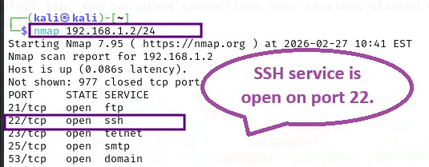
Figure 40. SSH service is open on port 22.
- To find known vulnerabilities for port 22, use “netcat” command. Run “nc 192.168.1.2 22” where 22 is the open port for FTP service. The vulnerability will show “”.
- Open a separate Kali Linux terminal and type “msfconsole”.
- Type “search OpenSSH” to search for FTP exploit.
- Type “use 3” or “use <name of exploit>” to select/use the exploit module.
- Set rhosts or the remote host by typing the command “set rhosts 192.168.1.2” where 192.168.1.2 is the IP address of Metasploitable2 VM. After that, type “show options” to double check it rhosts is set properly.
- Type the command “exploit”. This command is used to run the exploit. Take note that you need to run the command couple times until you are able to see a message “Found shell”.

Part 5.1.3 Use Meterpreter to upload documents
- Upgrade the sessions into Meterpreter sessions and use the Meterpreter to upload a sample document (e.g., a text file with your name) to the target (4 marks).

Part 5.1.4 Download document
- Download and use OWASP-ZAP (Web App Vulnerability Scanning tool) against the Metasploitable 2 (6 marks)

Part 5.2 For Windows XP VM
- Scan and exploit the target machine (exploit of your choice) (4 marks).
- Exploit the target machine using eternal blue (4 marks).

END

